2027-2029 MN ECO Cost-Effectiveness Advisory Committee (CAC) Meeting #3
October 18, 2024
10:00 a.m. – 12:00 p.m.

Type of Meeting: Microsoft Teams Meeting

Attendees: 27 online

Name | Organization | Name | Organization | Name | Organization
Adam Zoet | Commerce | Gregory Ehrendreich | Midwest Energy Efficiency Alliance | Lisa Beckner | Minnesota Power
Amalia Hicks | Cadmus | Grey Staples | Mendota Group | Luke Anderson | Xcel Energy
Andy Bahn | Commerce | Jaime Stallman | Great River Energy | Matt Wisnefske | Cadmus
Audrey Partridge | Center for Energy and Environment | Jake Millette | Michaels Energy | Michael Hinde | Minnesota Valley Electric Cooperative
Cassie Theisen | Minnesota Power | Jason Grenier | Otter Tail Power | Rachel Sours-Page | Mendota Group
Cory Hetchler | Connexus Energy | Jeremy Petersen | Xcel Energy | Tyler Glewwe | CenterPoint Energy
Cristina Zuniga | Otter Tail Power | Karl Shlanta | Xcel Energy | Wyatt Miller | Minnesota Power
David Pudleiner | ICF | Laura Silver | Commerce | Zach Froio | Applied Energy Group
Ethan Warner | CenterPoint Energy | Lauren Sweeney | Commerce | Zach Klabo | MDU Resources Group

NOTES

Meeting Began: 10:03 a.m.

Slide 1


Slide 2
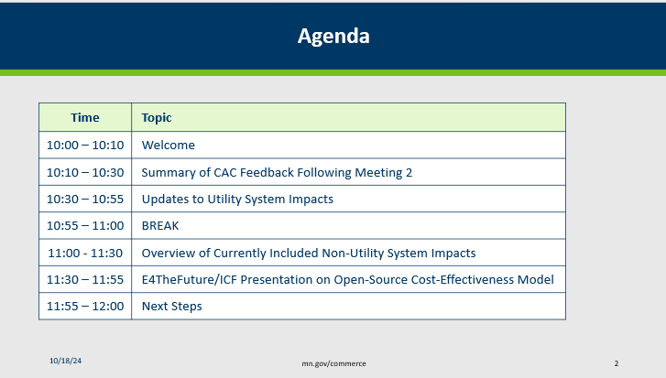

Slide 4
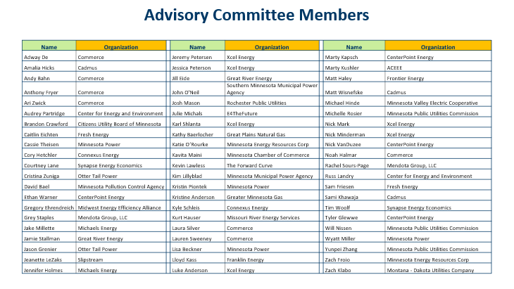

Slide 5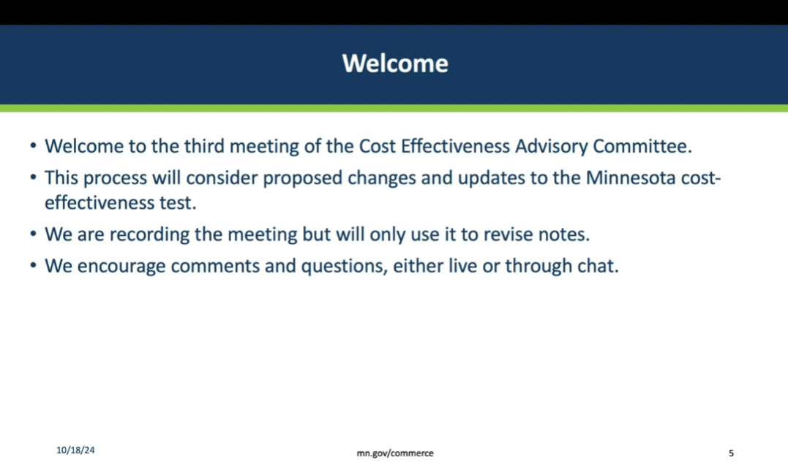

Slide 7
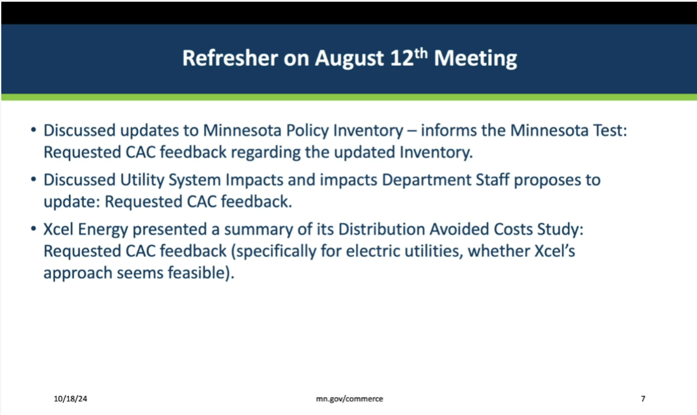
Grey Staples (Mendota Group) - The policy inventory informs inputs to the MN Test. To the extent there are updates to the policies, it’s useful to refresh the inventory. Although there were changes to MN law since the last inventory, the changes were not significant enough to merit changes to MN Test, with one exception (we'll discuss this in a bit).

Slide 8
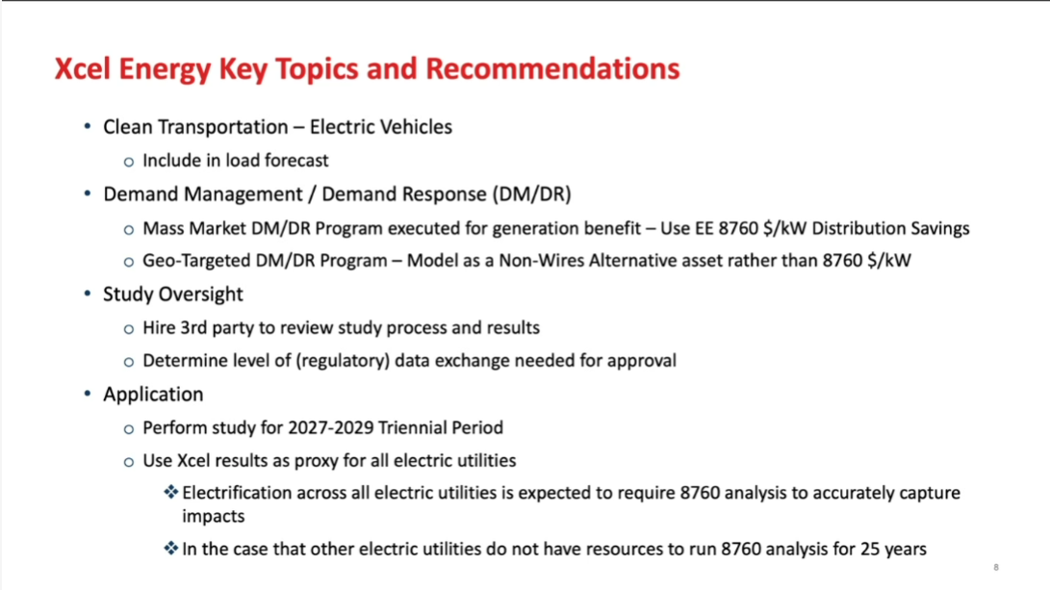
Grey - We are currently in the 2024-26 Triennial period. The 2027-29 Triennial Plans will be submitted in 2026. Xcel is considering using their distribution avoided cost method as a proxy for all electric utilities (potentially). Xcel, Otter Tail, Minnesota Power any updates?

Jeremy Petersen (Xcel Energy) - We are still considering going ahead with what we proposed – the hourly distribution study.

Jason Grenier (Otter Tail Power) – We met with our distribution engineers – we don’t have the modeling available to do the hourly. We will continue conversations to see if we can get software to do that. Some of this correlates with the Integrated Distribution Plan (IDP). Short term, probably going to use Xcel’s analysis and see if we can apply it in DSMore.

Lisa Beckner (MN Power) – Echos Jason. Met with Xcel and the distribution team. Starting to think about approaches can take similar to Xcel, whether manually or working with Xcel, or using LoadSEER. We don’t think this will be feasible by Dec 2025. We aren’t quite as keen on using Xcel’s study to inform our own. Not sure how well that would translate. Curious to hear from Jason how they might use that. Still moving forward but not sure what the timeframe will be and if we’ll need external software.

Grey - This is somewhat new for all of us, except Xcel. Two levels at which you could apply. First, the methodology. Second, actual values that could serve as proxies. I’m sure Jason has similar questions about whether Xcel values reflect their system.

Jason - Right there. Thinking we’ll use it as a proxy. We can’t say it’s inaccurate either. Long term, we want to have our own numbers.

Lisa - We haven’t found a way to include hourly values in DSMore yet. Now T&D is one cell for one year. Need to figure out a way DSMore could do hourly or find another approach.

Grey - DSMore is a single value and apportions based on load shape?

Jason - Yep, that’s how it works. Christina has had chats with the DSMore team, and they think there’s a way to do it.

Slide 9
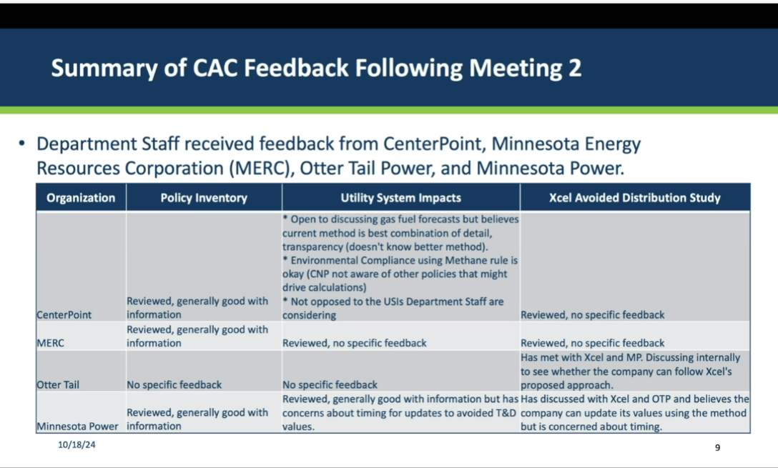

Slide 12:
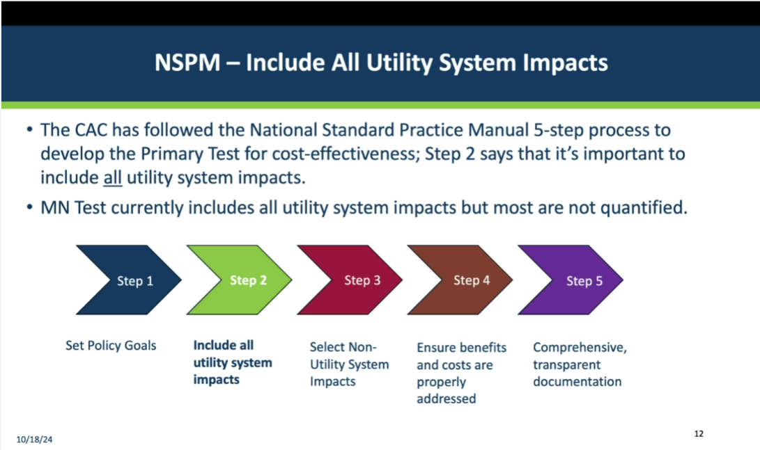

Grey - This is the sequence a jurisdiction would go through ... we went through this before to produce the MN Test. Step 1 is reviewing policy goals and why we are refreshing the policy inventory. Step 2 says to include all Utility System Impacts, but not all are quantified. Effort here is to figure out which we can review for update or add metric.

Slide 13
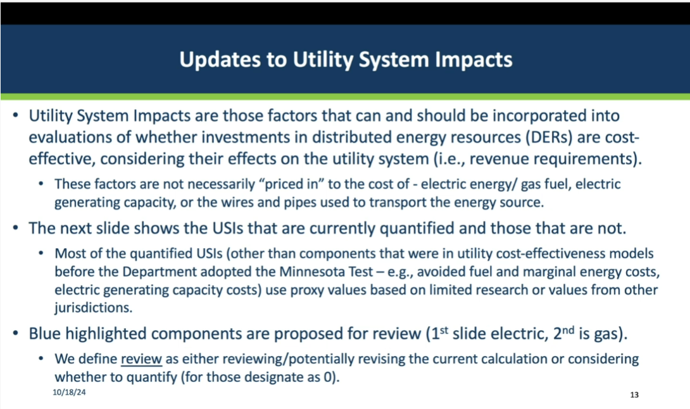

Grey – Updating Utility System Impacts (USIs) is relevant because the priced-in component will be part of marginal energy that’s already used in cost-effectiveness analysis. Don’t want to double-count. Key distinction. Whether item is part of existing component that is already being calculated.

Slide 14
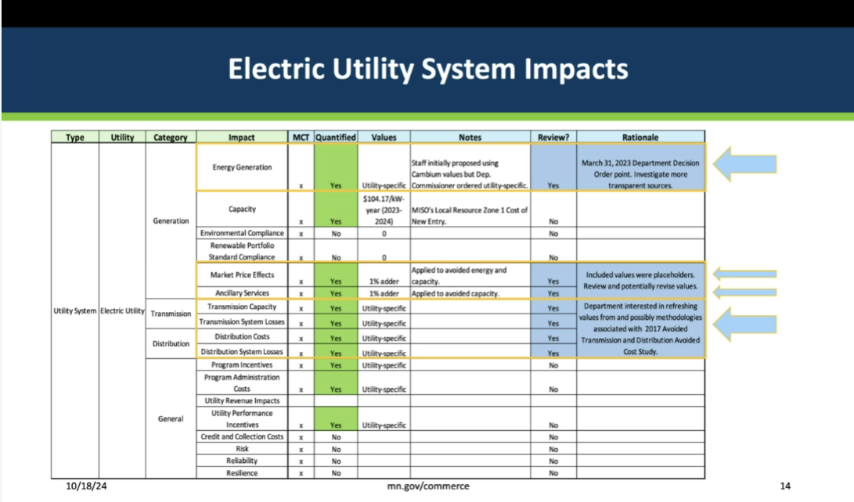
Grey - Blue highlights are the USIs considered for review and Deputy Commissioner wants to be more transparent because they tend to be developed with proprietary info. Staff initially proposed using values from NREL's Cambium model (https://www.nrel.gov/analysis/cambium.html). The Deputy Commissioner ultimately allowed utilities to their own values.

Grey - Need to review the market price effects and ancillary services to see if we can come up with better than the 1% adder applied to avoided energy and capacity for market price effects and to avoided capacity for ancillary services.

Grey - Xcel is looking to make the transmission & distribution (T&D) study more robust. Is focused on distribution system. Department Staff has questions regarding updates to transmission system values. Is there a MISO or other value that could be applied to transmission avoided cost values?

Jason - We advocated using MISO schedules for transmission allocation and our Regulatory folks indicated that makes sense. We could probably do some work to see if that makes sense here.

Grey - Thanks for reminder of your suggestion around avoided transmission costs. We would be interested in getting the additional information from your regulatory folks.

Slide 15
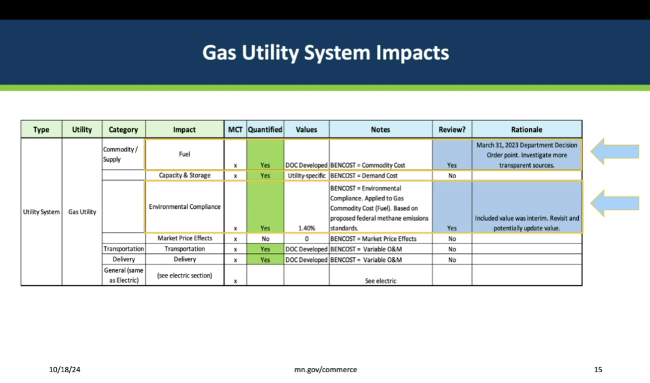

Grey - Potential updates to commodity costs. Currently using Purchased Gas Adjustment (PGA) values. CenterPoint is open to other methods but feels that the current method is best. Department Staff are looking for possible other commodity cost values that be more accurate than using historical values and yet remain transparent. Most methods and models tend to be proprietary. EIA publishes a lot of info, but only for a handful of years. In addition, the environmental compliance component was considered an interim value. Modest set of items for gas. We also have proposed non-utility system impacts to discuss.

Slide 16
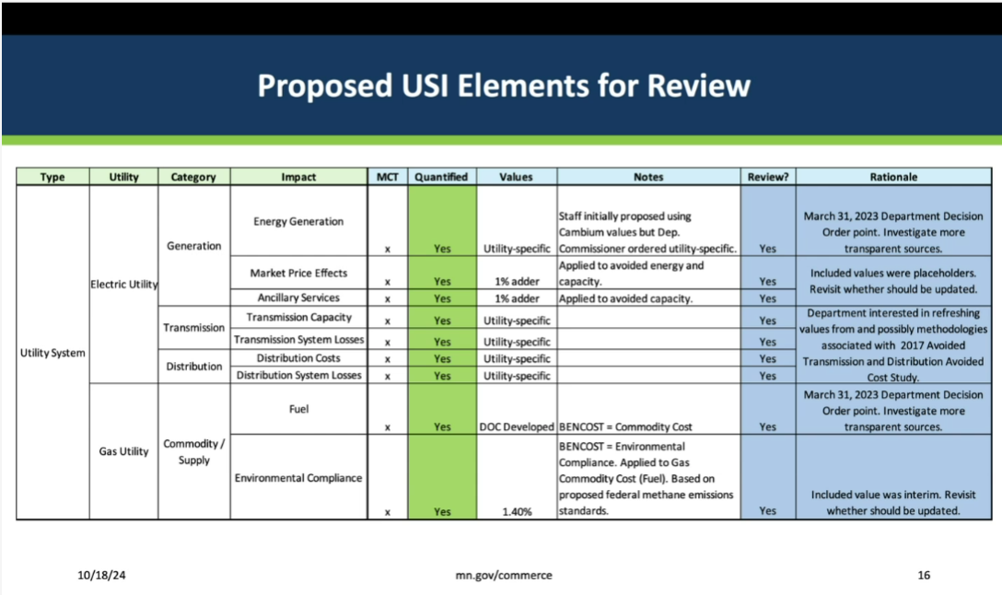

Grey - In most cases, those up for review had proxy values previously or need a more transparent source for info.

Slide 17
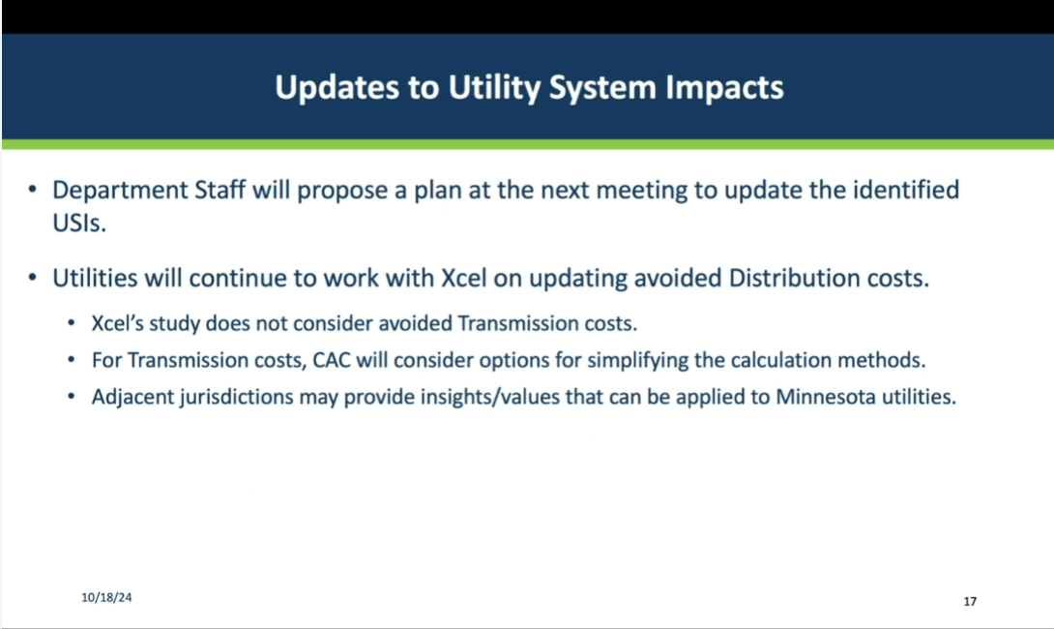
Grey - Other jurisdictions may inform the process. We haven’t looked at other jurisdictions in any detail, but they might have useful info. If anyone here participated in other jurisdictions, like WI, and could provide information, that would be helpful.

Adam Zoet (MN Dept of Commerce) - Any thoughts people have about the methodology for estimating the avoided marginal energy cost on the electric side? If anyone is aware of data sources with up-to-date information that can be shared more publicly. Have utilities given additional thought to using Cambium data? On gas side, related to the commodity cost input for BENCOST, if anyone knows of accurate, publicly available forecast gas prices that we could incorporate into this process, that would be helpful.

Jason – Possibly there are ways of getting there. If we have proprietary data, we’re going to keep it proprietary. But in terms of what public sources of data are out there, there’s definitely MISO files of day ahead and real time prices for energy markets for each hour. Those are places where we settle up. Every day we bid in our generation resources. And those get paid every day. And we’re also bidding in our load. And we have to pay for load every day. There is a disconnect between generation and our load. So, when we look at what we spend on energy, it’s not always aligned with what our load is. Some of it is proprietary, but if you wanted to get more general and just look at MISO real-time prices, which is where everyone settles, and it depends on which node you’re looking at, that could be something that’s a proxy that gets you there. Maybe the utilities still use our avoided costs, but if there’s a third party out there that’s really interested, they can look at MISO hourly prices for relevant nodes - that’s going to be pretty darn close to what we use. There are always third parties asking, not sure why, because you can go to MISO now and get the prices.

Audrey Partridge (Center for Energy and Environment) - I have a question, maybe for you Jason. In several dockets, including in Xcel’s Time of Use (TOU) docket, there’s debate about whether we should be optimizing for the specific resource mix or optimizing for MISO. I don’t know the answer. I think what I’ve heard is that there’s different outcomes potentially based on what you’re doing. In the context of energy efficiency and electrification, what are the trade-offs of looking at MISO where everyone purchases vs. utility specific resource mix, and would that result in different outcomes for energy efficiency and electrification programs, and what would those be?

Jason - I can’t speak for Xcel. You’re talking about two different, probably fairly close, but two different markets in a way. One is the actual market, the other is embedded cost - what does it cost to run our generators? I think those are two different things. If you’re not relying on your own generators, then you’re buying from someone else. Depending on the time of day and season, it will fluctuate. It’s a hard one. Gets complicated fast. I’m sure Xcel is just like Otter Tail. We bid our generators in the day ahead, and we know they’re going to get paid as long as they show up with that generation. We also bid our load in, so we say hey, we’re going to have 900MW at this time tomorrow and here’s the day ahead prices. We bid our load management, too. On these hours, we can take 20MW off our load, whatever it is depending on MISO prices. On the energy efficiency side, when are you realizing those energy savings. Are those hours that you’re settling when maybe load was higher than what you said it would and you’re sending it real time and you’re more exposed to the market? Or did your generation not show and have to true up in the real market. It gets complicated quickly. Very difficult to model accurately.

Jeremy - Our rationale for not using MISO directly is that it’s already included in our dispatch model and how much are we getting from MISO vs. how much are we influencing MISO each day. What is the ratio of how large our EE portfolio is vs. how much are we getting from MISO each day? Are we having bigger effects on MISO? We’ve always just looked at our effects on our own generation system.

Audrey - Is another way to put it, if optimizing around MISO, you’re optimizing around market/real costs. If optimizing around the utility’s specific system, you’re influencing and optimizing around that generation mix. We in MN have control over the utility-specific generation mix but not MISO market? This is our jurisdiction in which to make change, and that also does influence the MISO mix.

Jeremy - I think that’s accurate. In our Independent Resource Plans there are objectives that we meet that may not be reflected in the MISO markets.

Jason – But we’re settling at OTP-specific nodes. More of a regional node. It’s not like it’s energy from Indiana. Likely in 3-4 state area. PUC still has governance over most of that generation. Some can be Minnkota, some Great River Energy that’s not under the MN Public Utilities Commission, but likely regional generators.

Grey – When it comes to dispatching generation, I think it’s MISO that decides based on day-ahead what will be dispatched at which time. In that sense it’s regional, even if using local generation.

Jason - I agree with that.

Audrey – I will flag this to make a connection with Andy Bahn. He’s been involved in the TOU conversations, which are related. I want to let the Department know that these conversations are happening and that they’re somewhat related. The question of what price signals are appropriate. Utility or market? I don’t have an answer. One thing that came up - may be different for OTP - what’s noticeable, Xcel’s forecast peak periods didn’t align with MISO peak LMP because Xcel has significantly more solar than MISO north; so Xcel's peak is later when sun goes down, rather than earlier for MISO north, which is earlier in the day.

Jeremy - Not sure of all details but do believe we have more solar generally than is on MISO.

Audrey – Then, to the extent you are adding electrification measures or doing energy efficiency, the value on Xcel’s system is higher in the evening hours than value in the middle of afternoon when MISO value is highest. It points you in a different direction. It’s more meaningful when looking specifically at demand response, but still important when talking about electrification and looking at those load curves.

Jason – Good problem to have. When Xcel peaking, MISO has excess power.
Audrey - Yes, it’s a good problem to have but the question that’s come up is should Xcel tell customers with price signals to use less energy when MISO is peaking or less energy when they’re system is peaking? Don’t overlap. Historically, they’ve been the same time, but now looking substantially different. If you say everyone use less power in the middle of the afternoon, then you’ll see more use in evening. That’s when Xcel is peaking. If you use MISO signals, you’re pushing into Xcel’s actual peak. If you tell customers to respond to Xcel signals, then you’re pushing into MISO’s peak.

Jason - I think you have to always think about Xcel’s generation. Lots of generation in the afternoon when customers aren’t using it. And so now they’re going to get paid a great deal for that generation. And now that’s all going to flow through the fuel clause, and it’s going to go back to customers. Later in the evening, when Xcel’s loads are high (MISO’s already told them prices during that time), it’s going to be cheaper. Xcel is going to send those price signals to use then because nobody else is peaking. On both sides, their generators are getting paid a lot when MISO is peaking and then their load is higher, but getting cheaper energy for their peak. If you want a resource for this stuff, I have great one.

Jeremy - I don’t know all of these details, but we definitely need to look at difference between Xcel and MISO peak patterns to see if there’s some difference there.

Audrey - What is the result over long term of these two options – what does that tell Xcel to invest in for their resource mix? How does that shape what Xcel will invest in? How does it shape future resource procurement? What do we want them to be doing? I wanted to flag this issue. I didn’t weigh in, and not sure of nuances, but wanted to flag it as something for the Department to think about it. The tradeoffs in more transparency but less specific costs vs. less transparent, but specific costs. What are the tradeoffs and long-term implications depending on these different data sources?

Jeremy - The last time, we argued to look not only at dispatch of energy generation, but all the generation build decisions - why we suggested using a that proxy plant. We still believe that we can’t rely just purely on dispatch.

Karl Shlanta (Xcel) - Yeah, as we look at the correlation and the connections between our marginal energy prices, the carbon emissions, and source energy factors we need to be calculating, especially for efficient fuel switching measures, making sure we have that alignment in all of this is important. ACEEE did a report on GHG emission methodologies for energy efficiency and suggest the best was a longer-term ‘consequentialist’ method. There is still value into looking into future piece there. How procurement of energy efficiency and efficient fuel switching will impact the way we need to build the system of the future from both the carbon and the marginal price perspectives. We do model out 20 years, or account for the value 20 years out, so there’s a long-term component baked in. But it’s assuming load isn’t changing that much. But because of efficient fuel switching and energy efficiency, especially efficient fuel switching the way that those loads can be added will certainly change some of that build. The way that those are both adding to load and taking it away will change the procurement of resources. And needs to be taken into account in the future for that marginal price. And then the source energy as well.
Karl in chat - To chime in on the Cambium question: Xcel didn't necessarily have concerns about cambium as a source, but rather the fact that it came up in the proposed decision without much time to "kick the wheels" and figure out which scenario to use, which region to use (MN or a Load balancing area), and also if we should be using this for determining the CO2e (Short term vs long term) and source energy factors. I think there is value in using it but I think if we are going to use a public source we should agree on the right way to use the source as an advisory council.

Grey - Audrey, you summed up the trade-offs in terms of interest/desire for transparency vs. accuracy and utility-specific values. Maybe there’s more value in the proprietary info if it’s more accurate and sends the appropriate signals. Back to Cambium, NREL developed it using MISO data. There wasn’t sufficient time to evaluate the Cambium data before, but it’s possible that there are publicly available data sources. Or utility decides that their own marginal energy information isn’t proprietary. Based on our last conversations, we weren’t yet at that point. I feel like maybe Xcel said it was ok to present that information?

Karl - Yes, in the filing, we provided both Trade Secret and Public versions of the calculations of all of our avoided costs. We said we’d provide trade secret versions if folks signed an NDA. That allowed us to share the info, but didn’t want it to be used for other purposes. That’s largely been our concern with the marginal energy information. We’ve had concerns in the past that providing that data could help some market actors, it might influence bids and thus harm consumers, so needs to remain trade secret.

Around Cambium, no issue with source, it’s just the methodology for using it. It was in the proposed decision that we should use it. But that wasn’t sufficient time with the advisory committee to figure out what load balancing area, what scenario are we using? Should we use long-term or short-term forecast? They give us a marginal energy source and a marginal resource? No alignment on what heat rates to use for a coal plant. Too many questions at that time to support the proposal (to use Cambium). Open to further review. Not question of source, but how to use it.

Grey - For those who may not have picked up some of the other threads that Karl was weaving in, the tests by which utilities evaluate efficient fuel switching - utilities consider what’s in the cost-effectiveness model for energy and capacity values, and distributed energy values reducing with energy efficiency or increasing with efficient fuel switching; but the other threads that Carl mentioned about avoided carbon was based on 8760 value in the previous ECO. The legislature changed the law has changed so utilities don’t have to use 8760 GHG emissions values or heat rates. Source energy is also considered. What impact will the EFS have on overall energy use - analysis is based on source energy that’s ultimately producing the electricity or the avoided gas. We had similar questions related to efficient fuel switching in terms of the source for those values. Not necessarily discussing here, but important. Going into 2025, gives us information about how different approaches and ways we can look at the marginal energy calculations. This is a good start.

Break. Currently 11:05, back at 11:10.

Slide 20
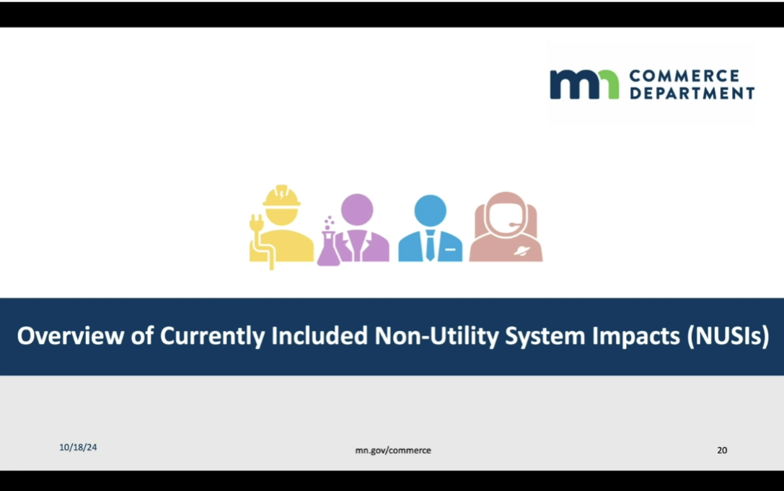

Slide 21
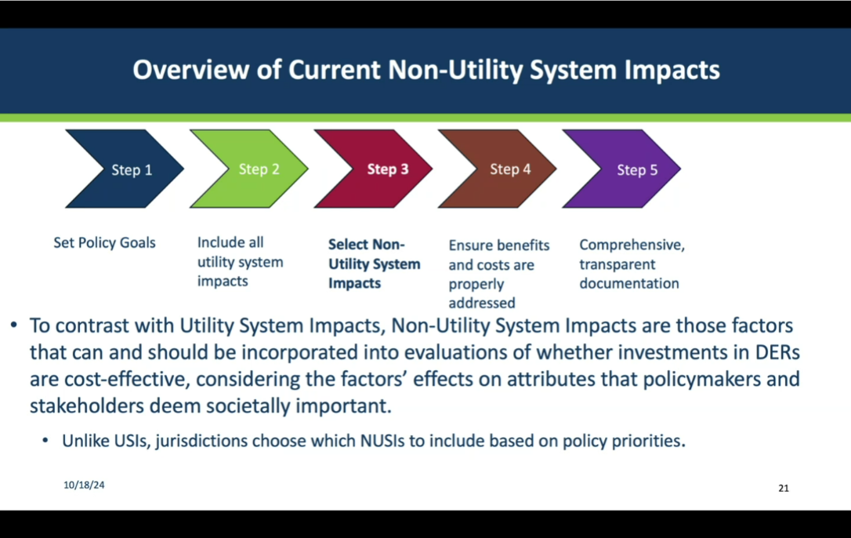

Slide 22
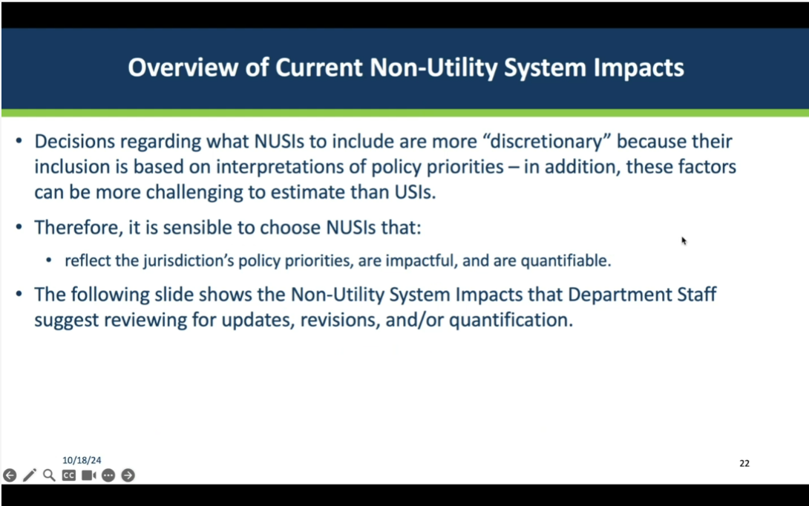

Slide 23
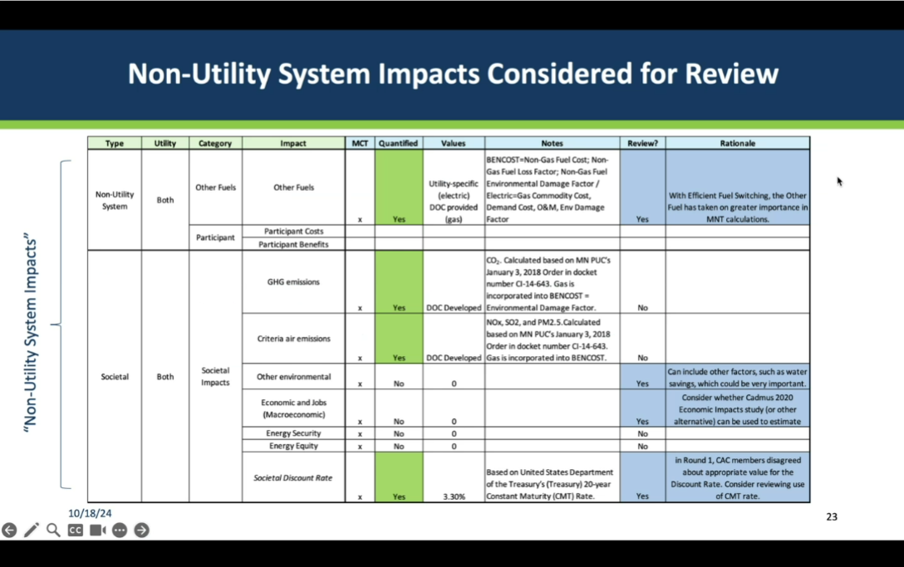

Grey - Blue highlights are those to be considered for review or quantification. Natural Gas BENCOST includes a non-gas fuel cost. So “Other Fuels” included in gas BENCOST is similar to how gas commodity costs are included in electric cost-effectiveness evaluations of efficient fuel-switching (EFS). With EFS, this has taken on greater importance. In gas BENCOST, we are considering changes to the electricity factors - because these, too, are important for EFS. Those quantified currently are in green. Two of the four need quantification. The Other Environmental category is a catch all for water, land use, and waste. Water savings is an important component to consider. Will apply to measures / DERs that impact water. Water has previously been considered in cost-effectiveness evaluations in terms of O&M - if customer saves water, they saving money, lowering participant costs; but, in this case water savings aren’t a NUSI. Change in legislature, adopted MnCIFA (Minnesota Climate Innovation Finance Authority. MnCIFA provides financing for sustainability initiatives. a financing mechanism created in law. [Lauren Sweeney offered acronym in chat.]

Grey - This is something we hadn’t previously included in the Policy Inventory. MnCIFA highlights the importance of energy projects that save water. We can apply this to utility distributed energy resources programs. Economics and Jobs is hard to quantify, but Department funded a Cadmus study in 2020 that looked at contributions from ECO to the Minnesota economy. Might be able to use that as a source.

Grey - Societal Discount Rate. Debate in round 1 about how to calculate it. Whether 3.3% (the adopted value) was too high. MN Test uses this as does Societal Test. I think Utility Test is only that uses Weighted Average Cost of Capital (WACC) instead. Based on US Treasuries constant maturity rate. The thought is to evaluate whether that’s the right value.

Karl in chat - Doesn't the Utility Test use the Utility Discount Rate which is the average of the WACC and the Societal Discount Rate?

Karl originally set as average between WACC and Societal Discount Rate. Reused that value for this one. Wondered if we’re going to update that this round.

Grey - In response to Karl chat, yes, Utility Cost Test uses a midpoint between WACC and Societal Discount rate. Was proposed by Department Staff. May be good to revisit.

Audrey - EPA and federal social cost of carbon – there was a good discussion around the new value they adopted. Whether Societal discount Rate should they rely on consumption rates? It’s an evolving conversation and way of thinking about how we value inter-generational impacts. The original California tests were developed when we weren’t as aware of climate change as a super long-term intergenerational event. They weren’t thinking of that time span; more focused on the time value of money. Lots of discussion around environmental impacts and whether discount at treasury rate…gives context for where conversation started.

Grey Thank you. We’ll put into the notes some of those references.

This is the link to the Intergovernmental Working Group report. https://www.whitehouse.gov/wp-content/uploads/2021/02/TechnicalSupportDocument_SocialCostofCarbonMethaneNitrousOxide.pdf And, an updated report from the Intergovernmental Working Group. https://www.epa.gov/system/files/documents/2023-12/epa_scghg_2023_report_final.pdfThese discount rates are specifically focused on valuing GHG impacts.

Karl in chat - Will the DOC look at Other Fuels like propane, gasoline, fuel oil or diesel?]

Adam - Regarding Karl’s comment in chat, it seems like we would want to align our cost-effectiveness approach as much as possible with the Department’s broader efficient fuel switching technical guidance. Would doing the cost-effectiveness analysis across a lot of unregulated fuel types introduce a lot of complexity?

Grey - Yes, it adds complexity. The ECO decision includes carbon values associated with those other fuels. Those are more static. Good question. Degree to which switches are happening? Most relevant switching isn’t propane or diesel, it’s gasoline, with lawn equipment, and EVs; probably the more likely switch from unregulated fuels. Something we need to think about. =Unregulated fuels include gasoline. Usually, energy efficiency only deals with regulated fuels (natural gas); but, in Minnesota, EFS can include switching from unregulated fuels, to include gasoline and diesel for EVs, lawn equipment, etc.

Audrey in chat - There may be quite a bit of switching from propane with ASHPs.

Karl - As dual-fuel utility, we had both gas and electric system impact on every program, you can see how we derived these values in our Triennial Attachment A. Curious if that’s something the Department will be looking into or if left up to utilities. Audrey had an important point about propane being important to look at in relation to switch from it to ASHP.

Grey - This is definitely true. I didn’t mean to diminish propane. Depending on where you are in the state, if no access to natural gas, then going to use propane. Yes, that’s within scope of consideration – what other fuels to consider and how to value them.

Slide 24
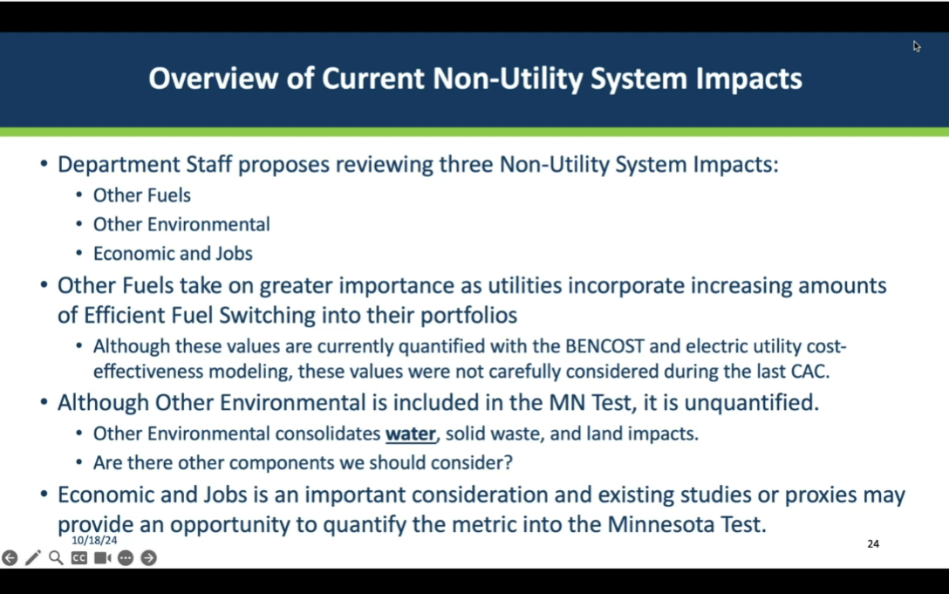

Slide 27
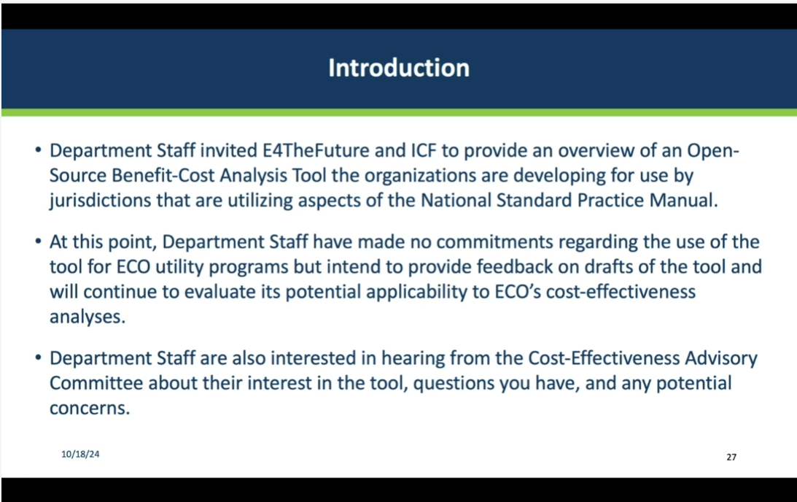

Slide 28
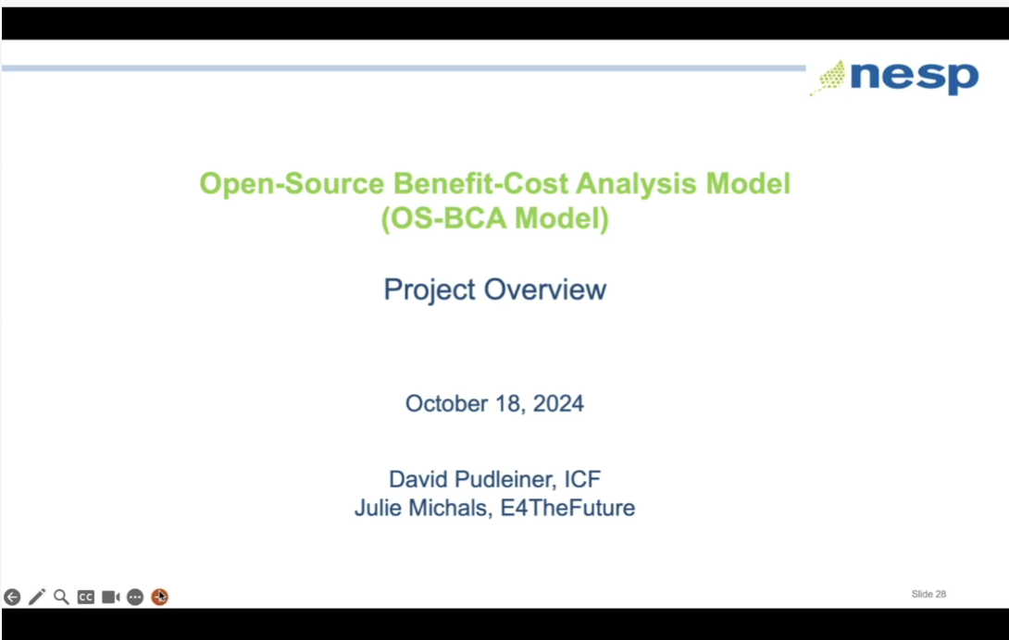

David Pudleiner (ICF) - Leads the building modeling team and most of the work around cost-effectiveness. Filling in for Julie Michals from E4TheFuture today. Short overview of latest developments in cost-effectiveness models. Recently awarded funding from DOE to do this work.

Slide 29
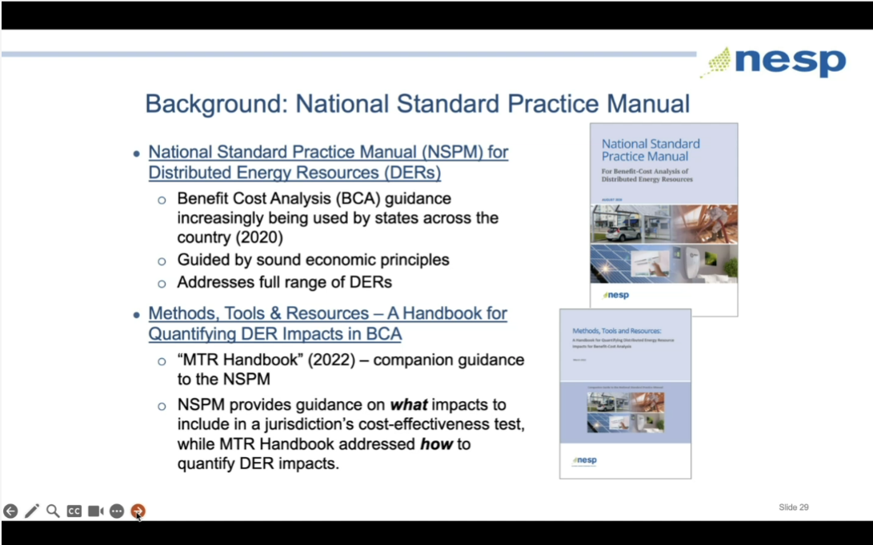

David – Thanks Department for its letter of support and for Recurve’s and LBL’s work.

Slide 30
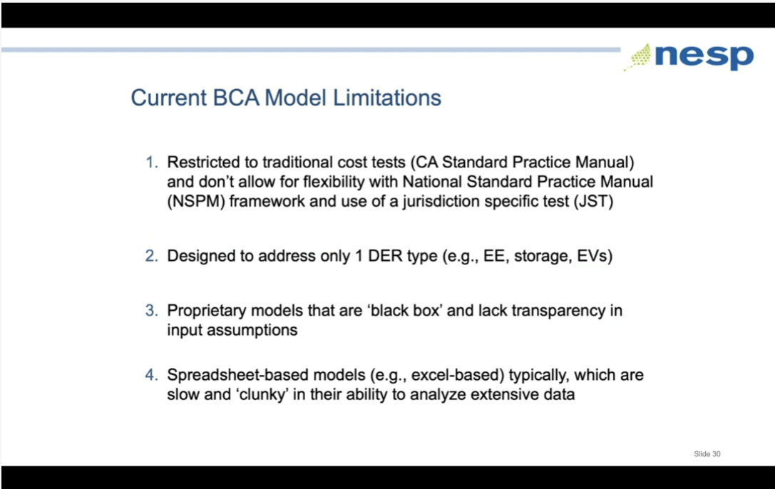

David - There are limitations in the current cost-effectiveness models used to evaluate programs. Many of the cost-effectiveness tools are only capable of calculating the traditional tests and don’t allow customization.

Slide 31
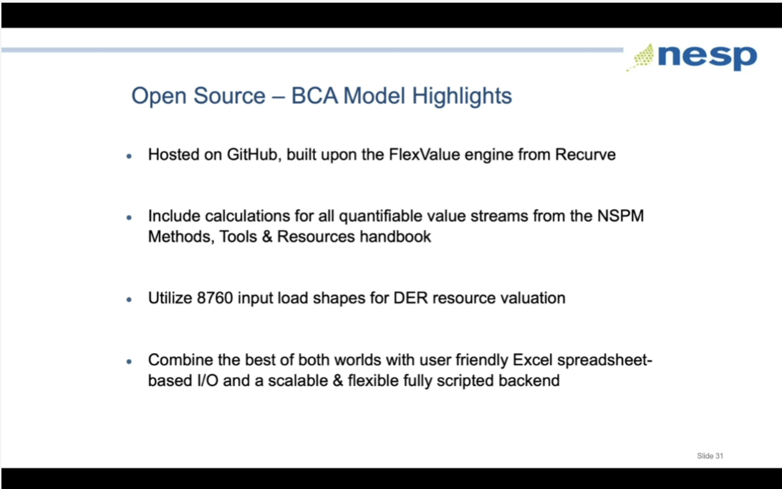

David - This is the tool they are building. User will not have to deal with code. Clean interface.

Slide 32
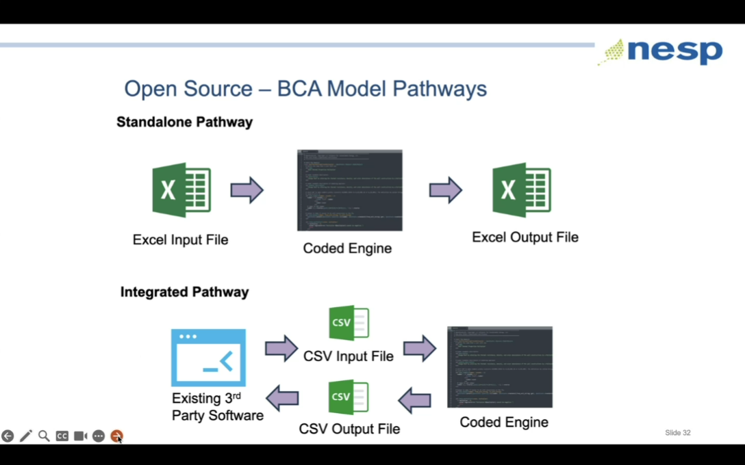

David - We will develop a set of validation cases to test against.

Slide 33
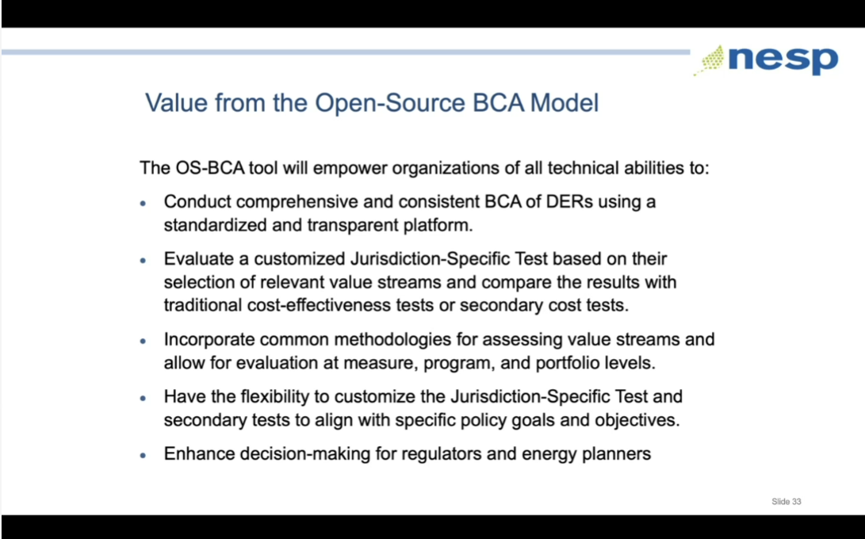
David - Ability to customize the Total Resource Cost Test in alignment with what jurisdictions have done.

Slide 34
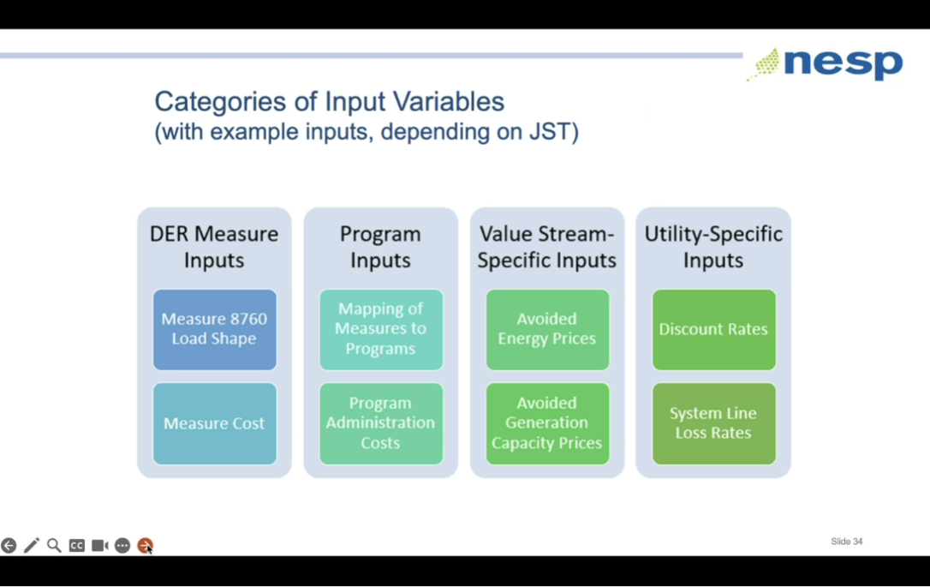

David - Intending to balance user effort and transparency. Will provide defaults for parameters such as Societal Discount Rate and line losses but accessible to modify. Nothing is locked down.

Slide 35
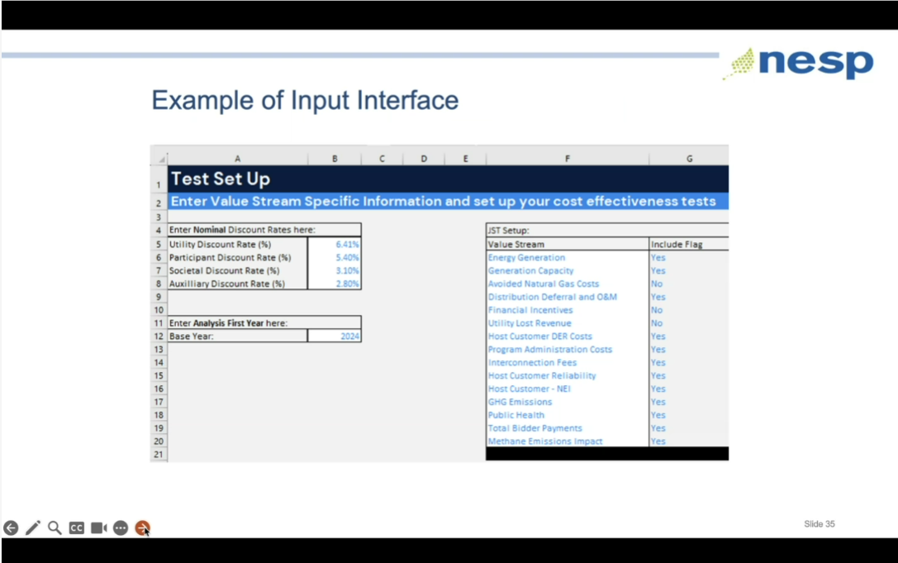

David - We are trying to balance the amount of info on each tab so accessible and not overwhelming. This isn’t final color scheme.
Slide 36
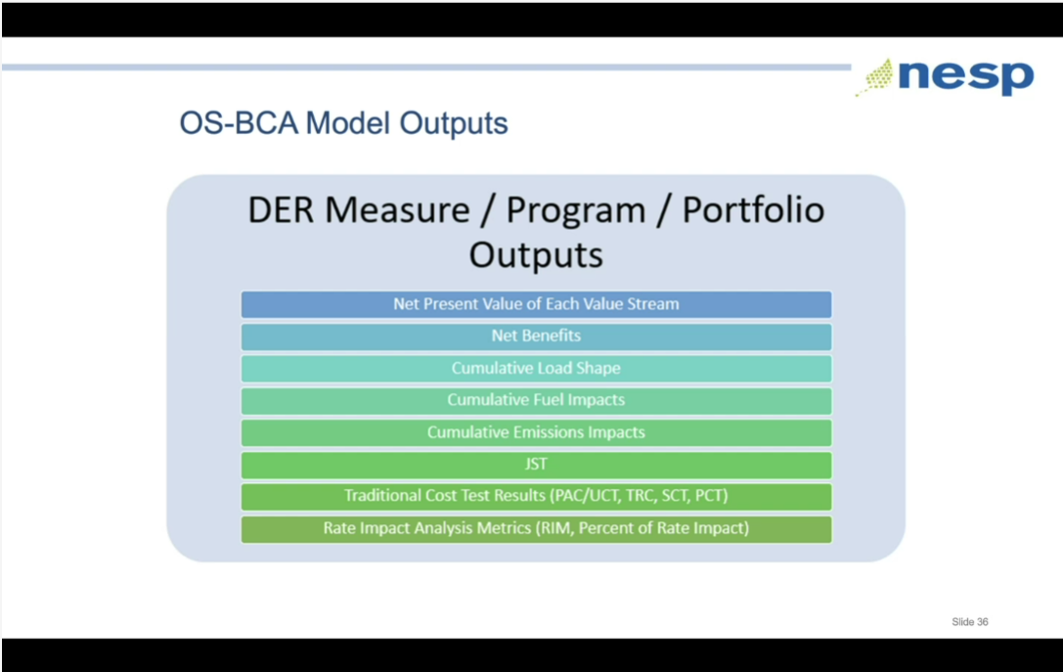
David - All tests available for output. Can report at measure, program, portfolio levels. JST = jurisdiction specific test.

Slide 37
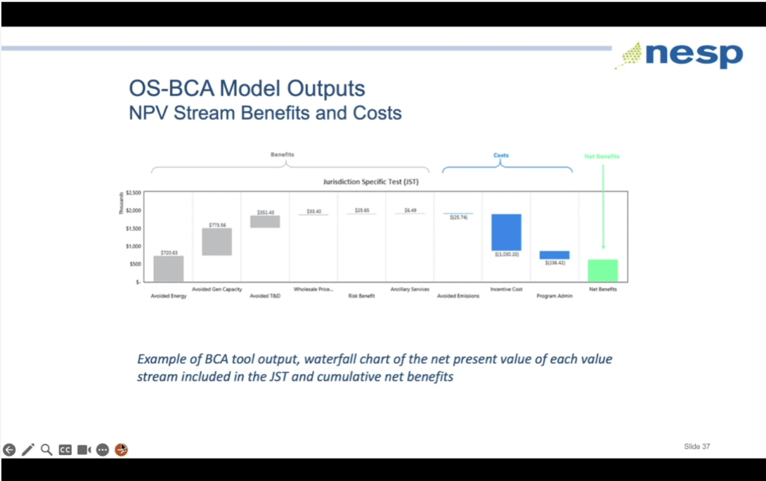

David - Graphics that will be available; I like this waterfall diagram. Waterfall charts show relative influence of different components.
Slide 38
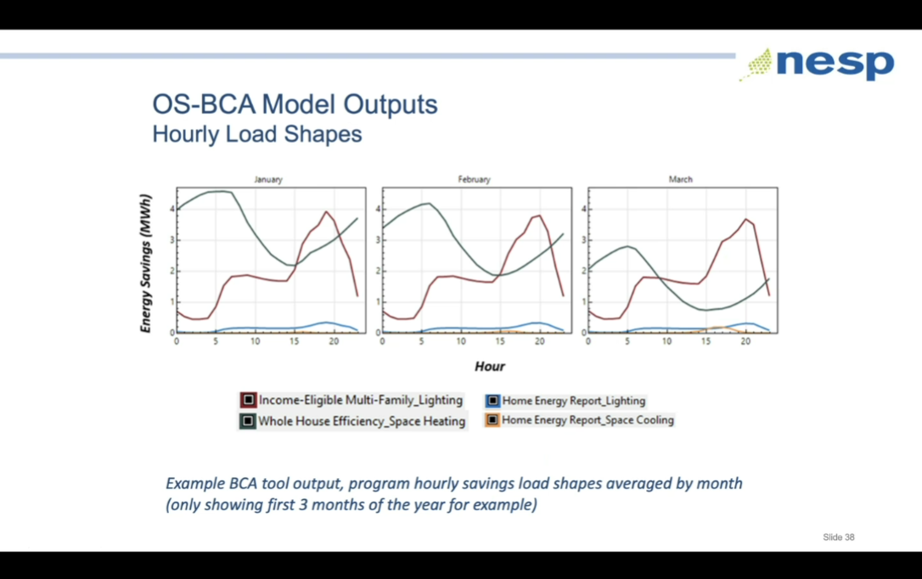

Slide 39
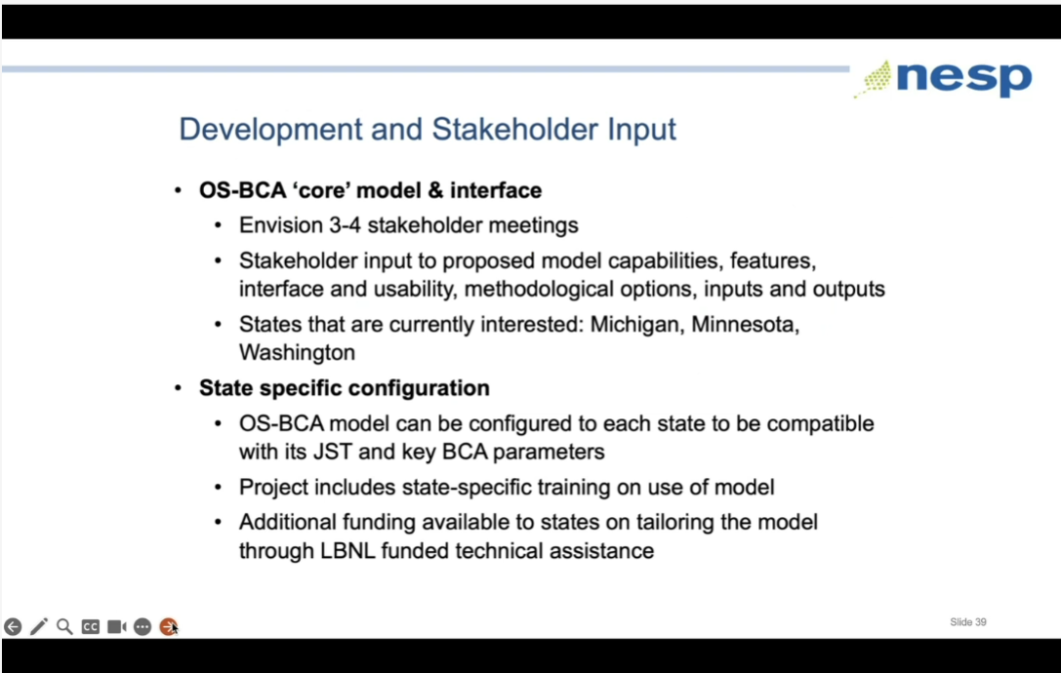

David - Development process for the tool. Once developed, there will be training resources. No project specific funding to help a particular state through the process, but there is LBL funding for help.

Slide 40
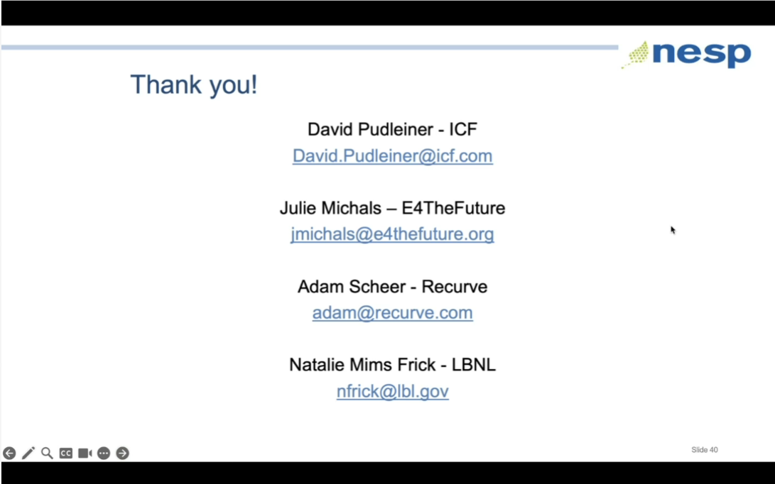

No questions.

Slide 43
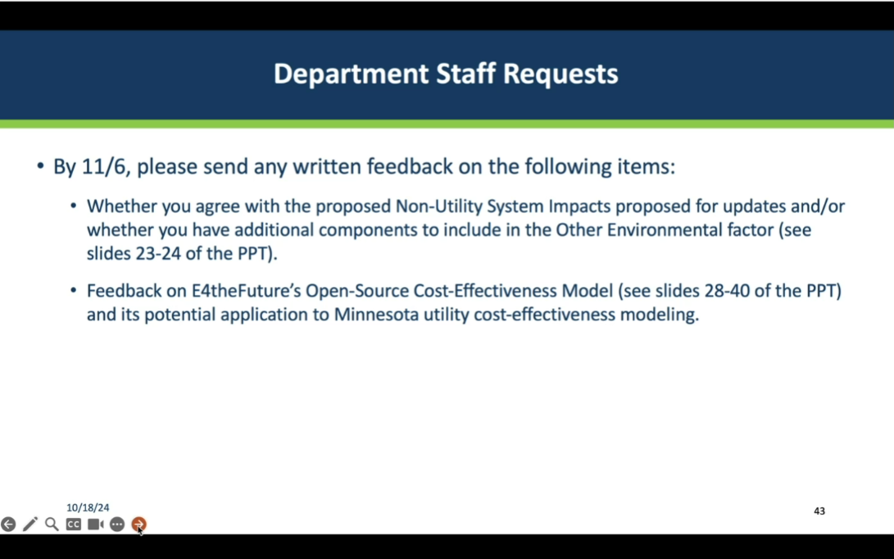

Slide 44
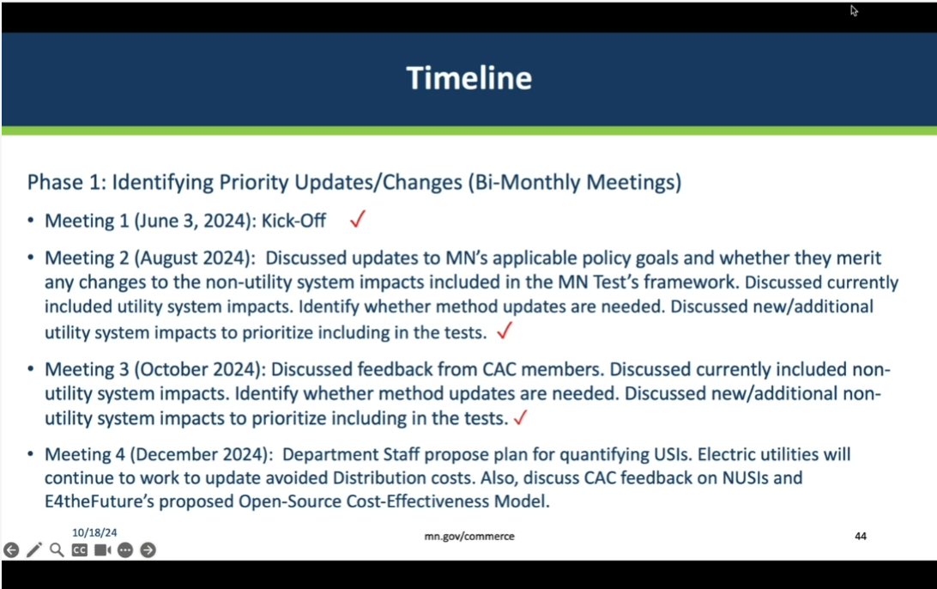

Slide 45
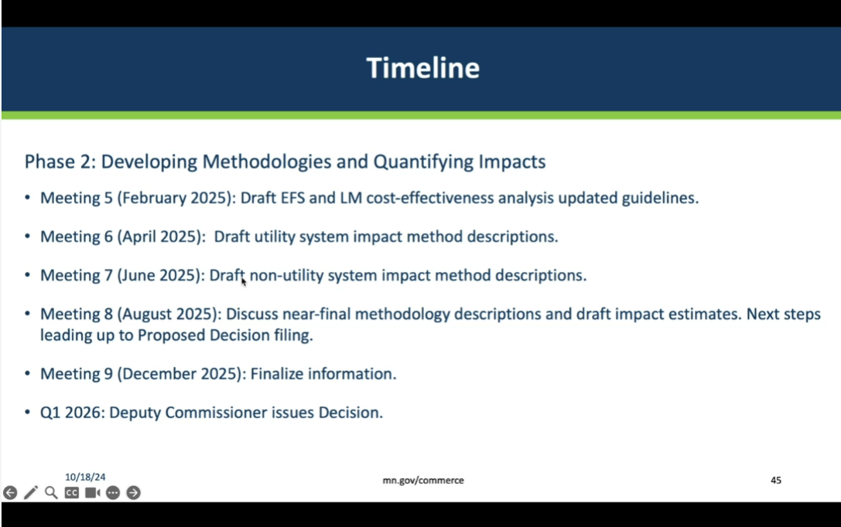

Slide 46
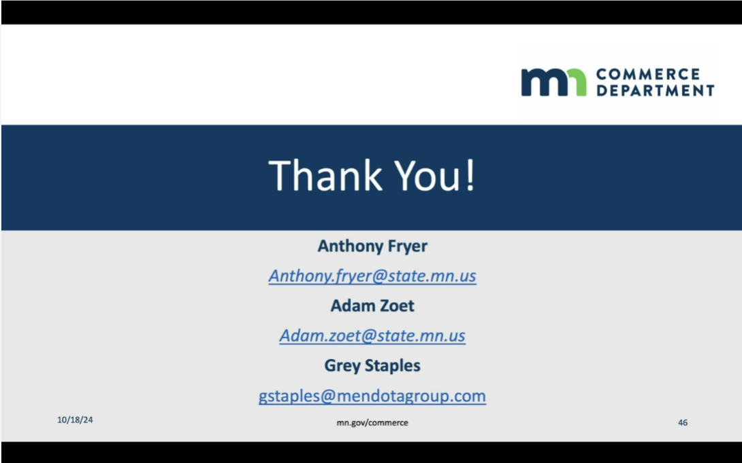

Meeting ended at 12:00 p.m.

https://www.aceee.org/research-report/u2401

